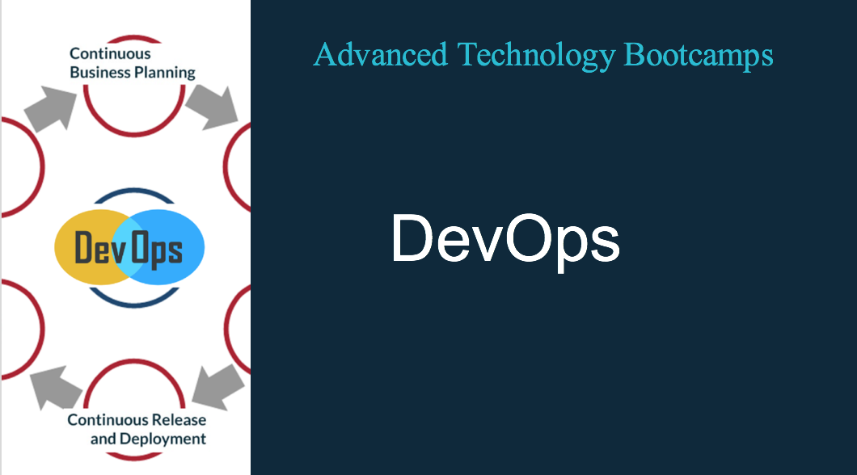

DevOps - Bootcamp

Pre-Requisites:
- IT background
- Basic programming knowledge
- Software Development Life cycle knowledge

Course Content:
This instructor led 3 Day bootcamp is designed to educate participants through DevOps methodology and culture. DevOps is the latest methodology that is being implemented in all the Software development organizations. DevOps engineer are in high demand. The bootcamp will cover not only cover the methodology but also tools that are required to create a DevOps environment in an organization.

Course Outline:

- What is DevOps
- What are Microservices
- What are containers
- DevOps as a culture
- DevOPs Adoption: What are the steps.
- Container technologies
- Deploying Docker Container
- Linking Containers
- Difference between Virtual Machines and containers
- Monolithic vs Cloud Native Applications
- Jenkins
- Git
- Other tools that are required to implement DevOps
- Transitioning of Existing organizations to DevOps model

Labs
    - Jenkins Deployment
    - Puppet Deployment
    - Mini project

